Christeen Safar

CSD - 340

03/25/2023

**Module 3 Assignment 3.2- Assignment: GitHub Pages**

**GitHub Link:**

[**https://github.com/ChristeenSS/csd-340.git**](https://github.com/ChristeenSS/csd-340.git)

**GitHub Pages:**

[**https://christeenss.github.io/csd-340/**](https://christeenss.github.io/csd-340/)

* Add a new file to your csd-340 repository and name it index.html (must be named exactly)
* Add a new file to your csd-340 repository and name it site.css
* Contents of index.html
  + Create an empty HTML document (follow the code you used in Module 2), add your name and assignment number (documentation).
  + Give the HTML document a title of  <your first name> <your last name>  CSD 340 Landing Page
    - Example: Johann Bach's CSD 340 Landing Page
  + Add a link to site.css file in the HTML documents head element
  + Add a main div to the body of the HTML document with an id of **container**
  + #container
    - Add an h1 tag and give it a text value of  <your first name> <your last name>  CSD 340 Landing Page
      * Example: Johann Bach's CSD 340 Landing Page
    - Add an h2 tag and give it a text value of  "CSD 340 Web Development with HTML and CSS"
    - Add an HTML horizontal line
    - Add an h3 tag and give it a text value of Module **Assignments**
    - Underneath the h3 tag add an unordered list with list items for assignments 1.3, 2.2, and 3.3, you'll be updating this as we go along.
      * Each list item will need an anchor tag that links to the HTML file you completed for the assignment, think relative links
        + Example: <a href="module-2/Sampson_Mod1_3">Assignment 1.3></a>
    - Add an h3 tag and give it a text value of **Projects**
    - Underneath the projects h3 tag add an unordered list with list items for **bioSite Project Home Page.** You'll be creating the files for this later in the course.
      * Each list item will need an anchor tag
        + <a href="">bioSite Project Home Page</a>
    - Add an h4 tag and give it a text value of Important **Links**
    - Underneath the important links h4 tag add an unordered list with list items for
      * W3C HTML Validator: <https://validator.w3.org/>
      * W3C CSS Validator: <http://jigsaw.w3.org/css-validator/>
      * HTML Tutorial: <https://www.w3schools.com/html/>
      * BRUIN Connect: <https://bruinconnect.bellevue.edu/>

<!DOCTYPE html>

<html lang="en">

<head>

    <meta charset="UTF-8">

    <meta http-equiv="X-UA-Compatible" content="IE=edge">

    <meta name="viewport" content="width=device-width, initial-scale=1.0">

    <title>Christeen Safar's CSD 340 Landing Page</title>

    <link rel="stylesheet" href="./site.css">

    <link rel="preconnect" href="https://fonts.googleapis.com">

    <link rel="preconnect" href="https://fonts.gstatic.com" crossorigin>

    <link href="https://fonts.googleapis.com/css2?family=Oswald:wght@300;400;500;700&display=swap" rel="stylesheet">

</head>

<body>

    <div id="container">

        <h1>Christeen Safar's Landing Page</h1>

        <h2>CSD 340 Web Development with HTML and CSS</h2>

        <hr />

        <h3>Module Assignments</h3>

        <ul>

            <li><a href="module-2/Safar_EX1.html">Assignment 2.2</a></li>

            <li><a href="module-3/Safar_EX2.html">Assignments 3.2</a></li>

            <li><a href="module-4/Safar_EX3.html">Assignments 4.2</a></li>

            <li><a href="module-5/Safar_EX4.html">Assignments 5.2</a></li>

            <li><a href="module-6/Safar_EX3.html">Assignments 6.2</a></li>

            <li><a href="module-7/Safar_EX4.html">Assignments 7.2</a></li>

            <li><a href="module-8/Safar_EX2.html">Assignments 8.2</a></li>

            <li><a href="module-9/Safar_EX6.html">Assignments 9.2</a></li>

        </ul>

        <h3>Projects</h3>

        <ul>

            <li><a href="/bioSite/landing_page.html">BioSite Project home Page</a></li>

            <li><a href="module-12/Gossett_Bio.html">MyBio Assignment</a></li>

        </ul>

        <h4>Important Links</h4>

        <ul>

            <li><a href="https://validator.w3.org/">W3C HTML Validator</a></li>

            <li><a href="http://jigsaw.w3.org/css-validator/">W3C CSS Validator</a></li>

            <li><a href="https://www.w3schools.com/html/">HTML Tutorial</a></li>

            <li><a href="https://bruinconnect.bellevue.edu/">BRUIN Connect</a></li>

        </ul>

    </div>

</body>

</html>

* + Contents of site.css
    - Hint: refer to Module 3, if you do not remember how to create/setup Google font kits
    - #container
      * Set the top margin to 50px
      * Set the left margin to 100px
      * Set the right margin to 100px
    - Set the h1, h2, h3, and h4 tags to a background color of your choice (you are basically creating a color scheme), a font color that can be readily viewed with the background color, a border of 1px solid and #D6A800, and padding of 10px
    - Set the anchor tag to a color that blends in with your color scheme and a text decoration of none
    - Set the anchor hover to a color that blends in with your color scheme
    - Set the anchor visited to a color that blends in with your color scheme

body {

    font-family: 'Oswald', Verdana, Arial, sans-serif;

    margin-top: 50px;

    margin-left: 100px;

    margin-right: 100px;

}

h1,h2,h3,h4 {

    background-color: #d53680;

    color: #fff;

    border: 1px solid #D6A800;

    padding: 10px;

}

a {

    color: #74365e;

    text-decoration: none;

}

a:hover {

    background-color: #D6A800;

    color: #b24a8a;

}

a:visited{

    color: #87335c;

}

* Validate the HTML by using the W3C HTML validator and correct any errors. Once you are happy with the results, take a screenshot of the validators results
  + 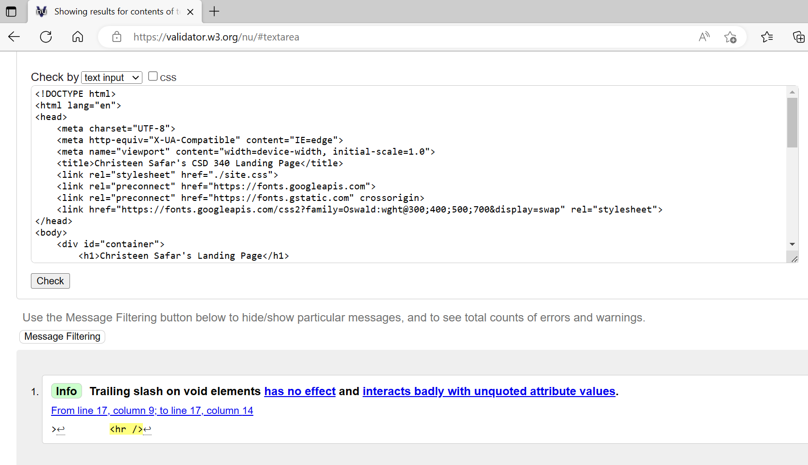There must be 0 errors

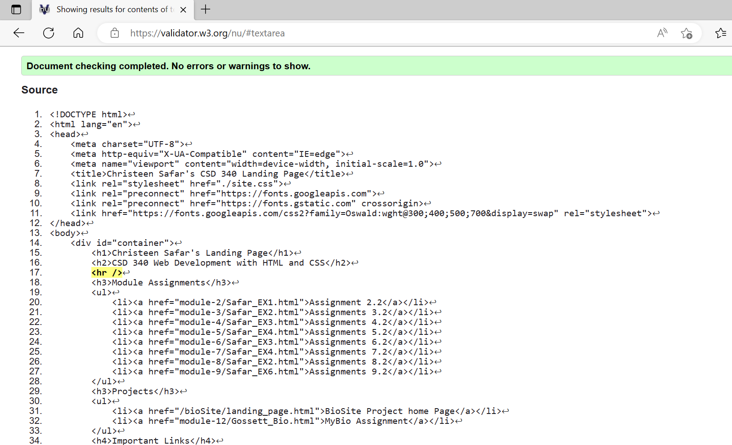

* Validate the CSS by using the W3C CSS validator and correct any errors. Once you are happy with the results, take a screenshot of the validators results
  + There must be 0 errors

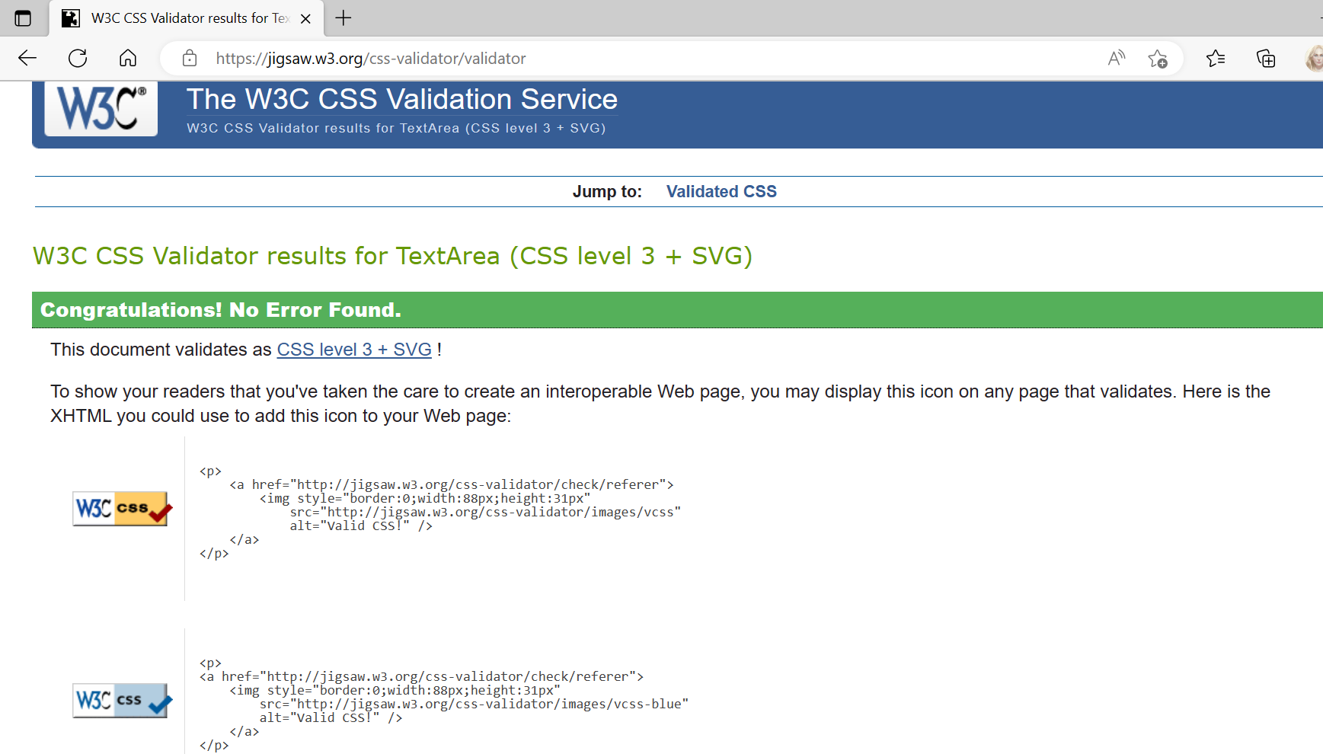

* Open your index page in a browser and take a screen shot of the results

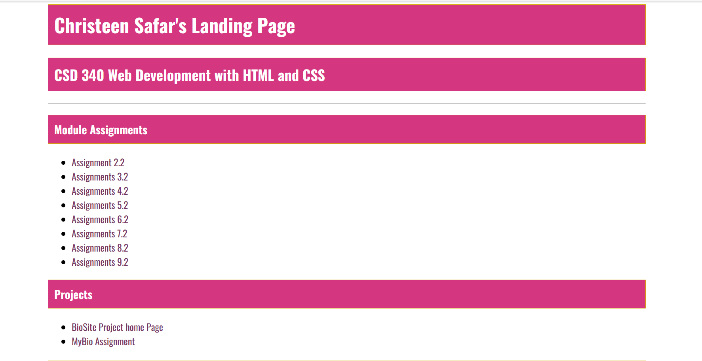

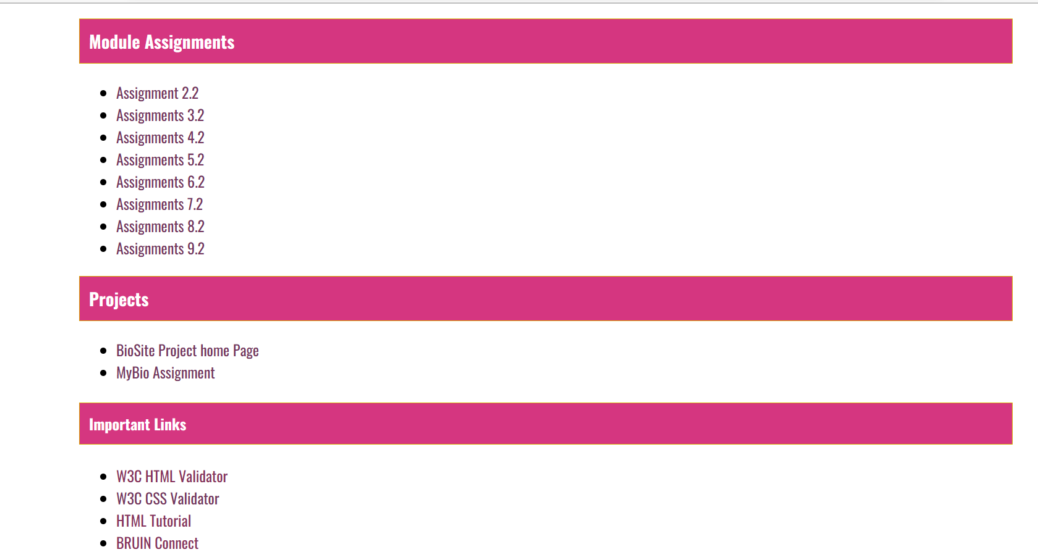

* Configure the repository for GitHub pages
  + Refer to the Reading and Videos selection for a document on how to do this

